Transformer Design

We use 495-5251-ND as a core. Its material is N41.

Bsat is nearly 0.4T.

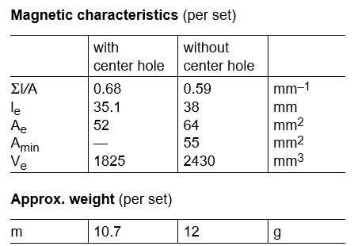

(1)

From the equation (1) N1>2

(2)

R=0.2 Ω

